Manage resources :

There is a Sql on-demand already (by default it is created in the workspace creation).

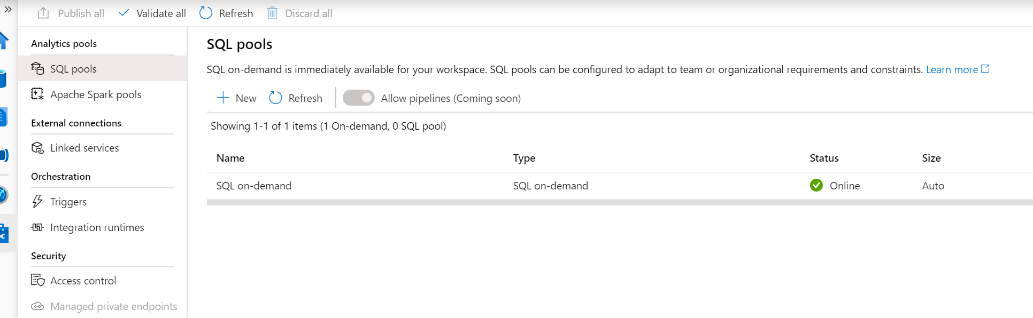

Create new Sql pool : A pool of DW500c

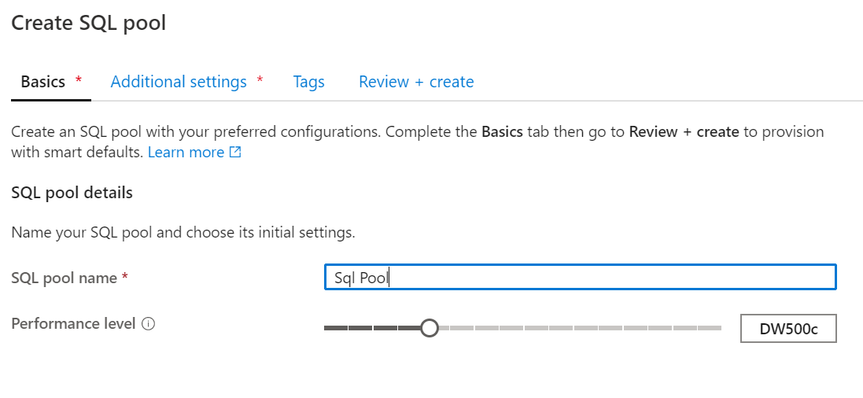

Create a sql pool New or from a Backup or Restore point

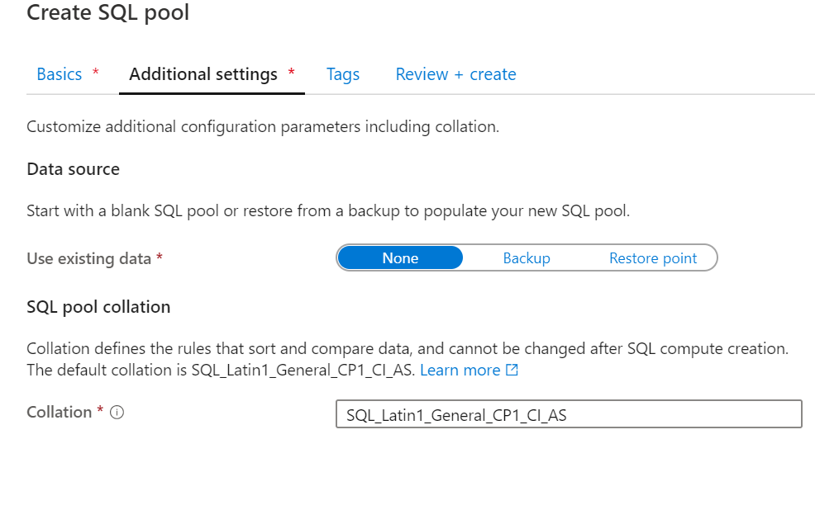

Review and create as below :

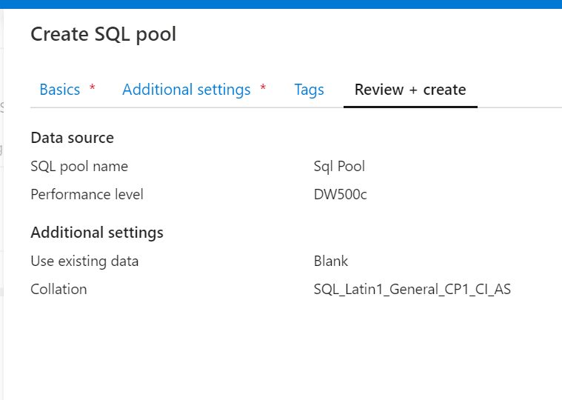

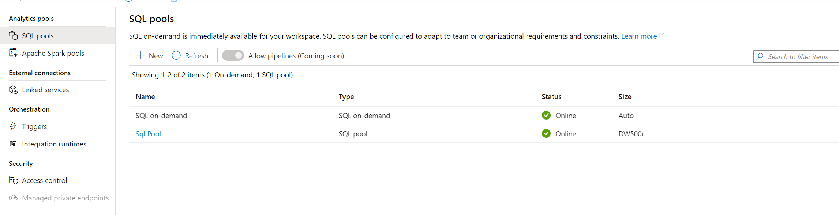

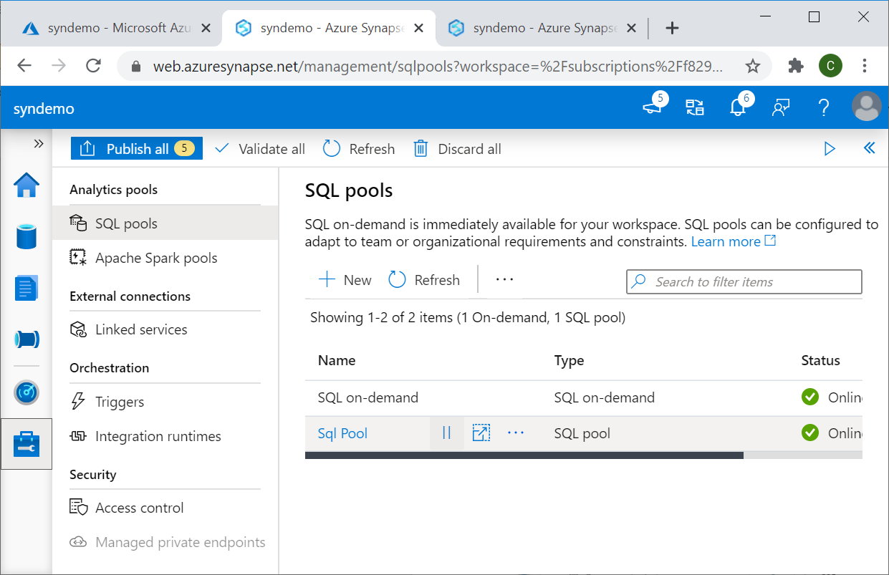

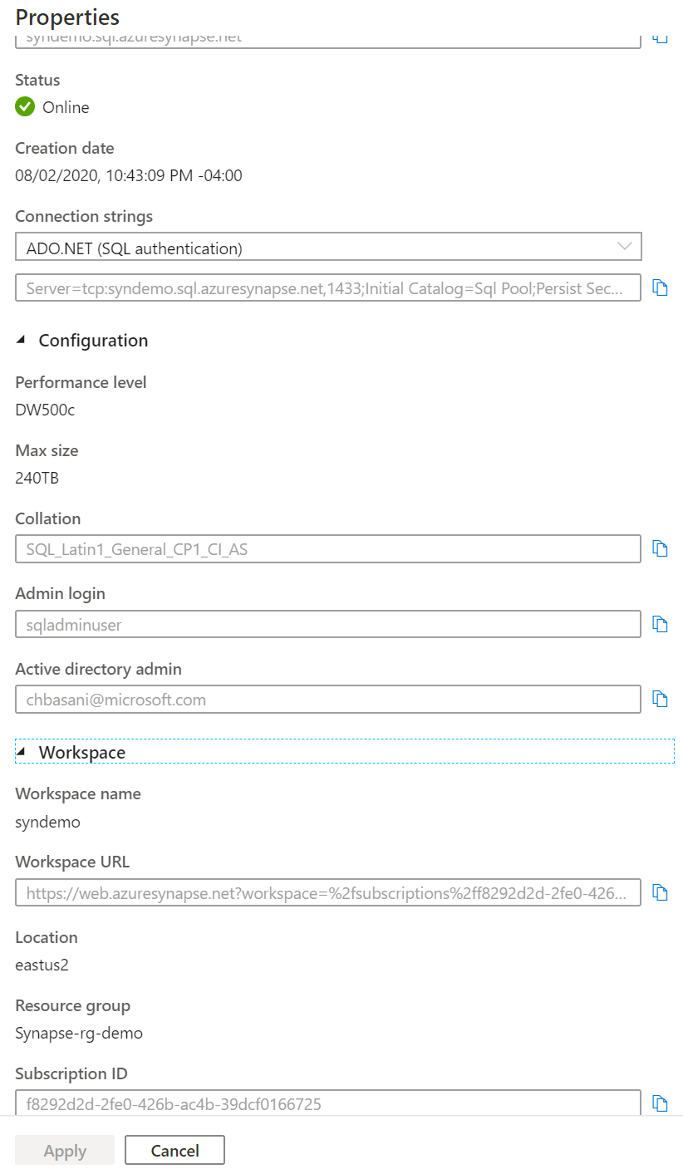

\*Create Spark pool :

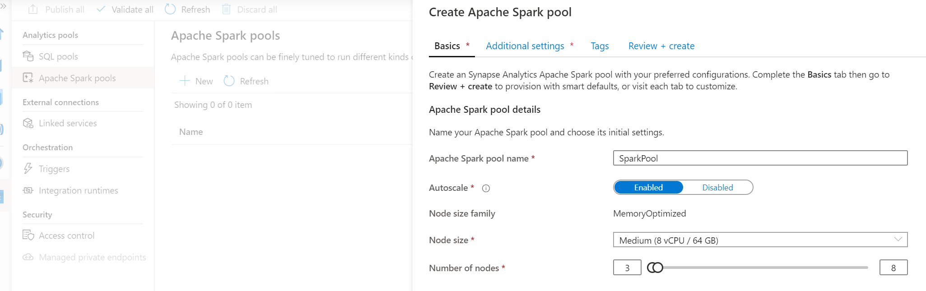

It creates a 3 nodes of 8 Core / 64 GB pool. Based on the processing needed, it will scale to 8 nodes.

You can disable the autoscale feature.

In the Additional settings,

You can choose to autopause (if not being used in 15 mins , change time as per the need)

Component version details. There is python kernel that could be selected in future release.

Packages that are needed for your spark environment.

You can add the needed packages using the requirements.txt file that you upload here .

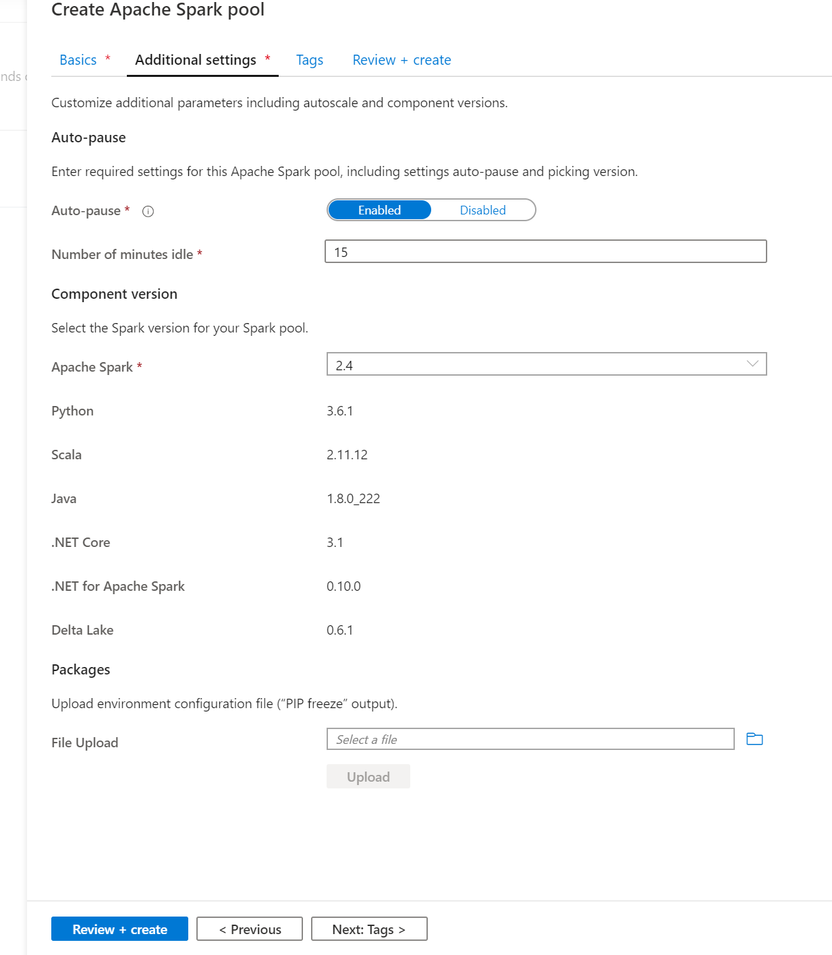

Review and create the spark pool needed.

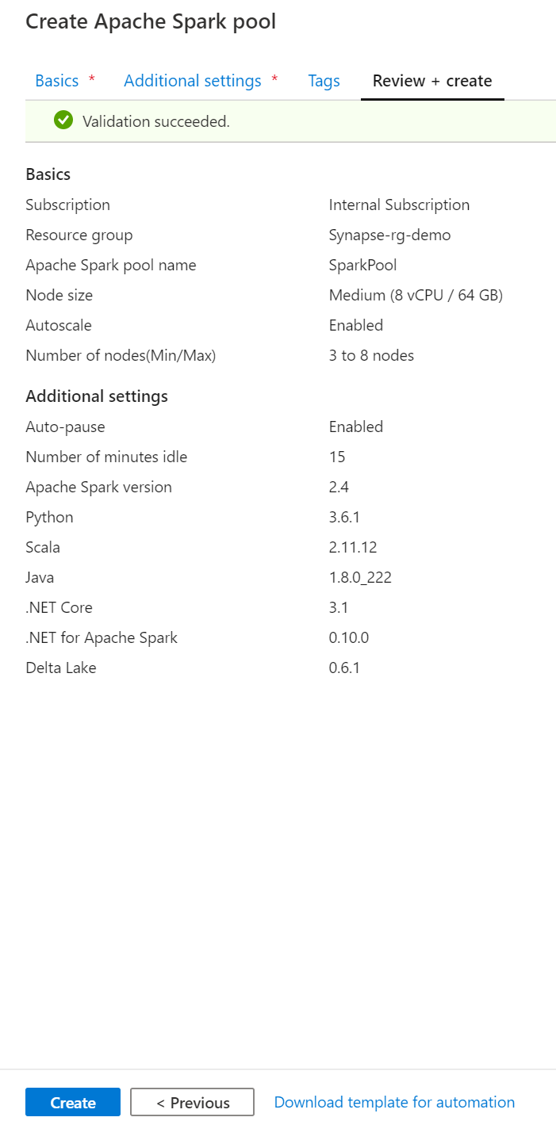

\*You can create the sql pool and spark pool or manage endpoints in the portal as well.

\*Linked Services : Here is the default datalake that we created. As more linked services are configured, you can manage the services here .

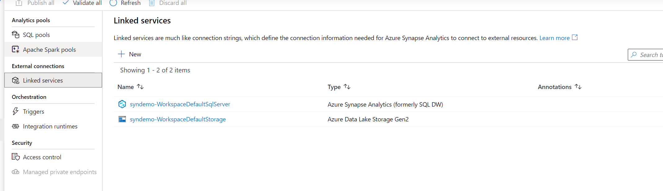

\*Integration runtimes :

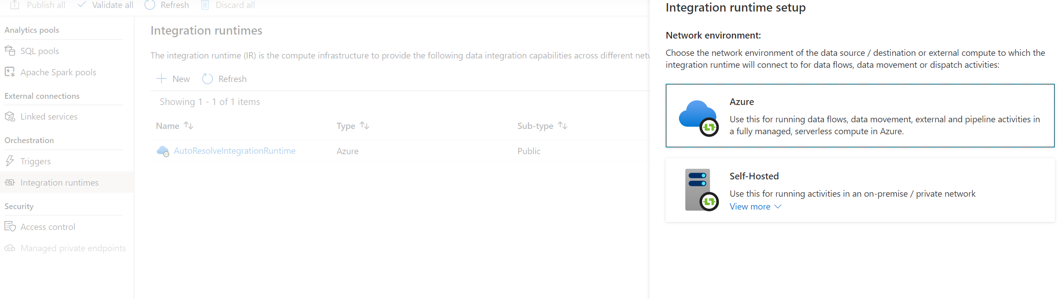

You can create the runtimes you need for the data factory ETL pipelines here .

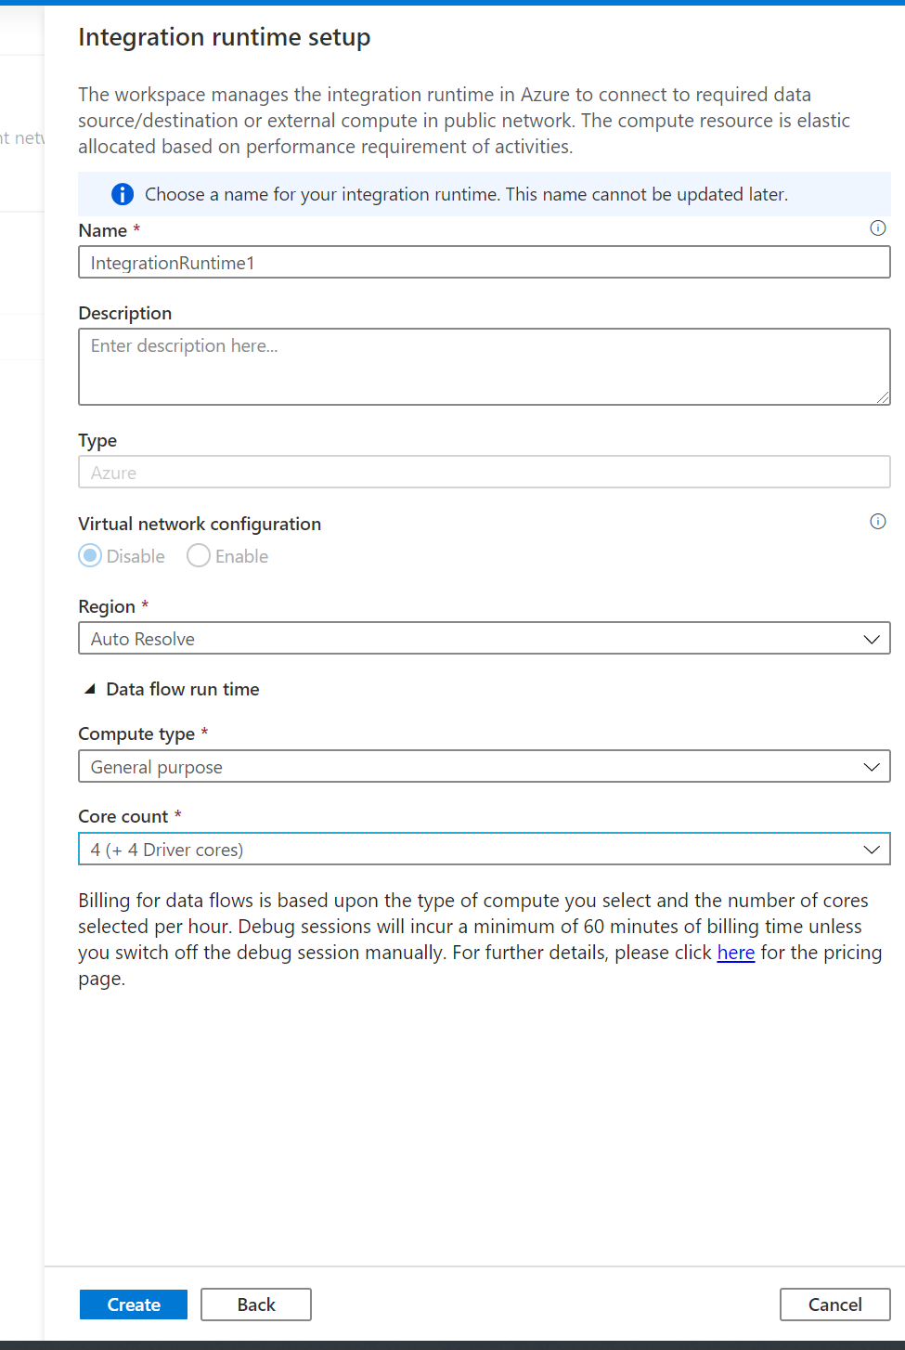

\*Access control and the private endpoints can be managed in the Manage Hub.